

Thefreshtest.com

Buy on website for $17

Make sure you get the 50g. Mix powder with 10oz of water.

**Alternatives to the glucose drink are:**

**-15 large Brach Jelly Beans**

**-50 Jelly Bellies or**

NAKED JUICE-

Guava Fruit, Pina Colada or Rainbow light Smoothie, 15.2 OZ

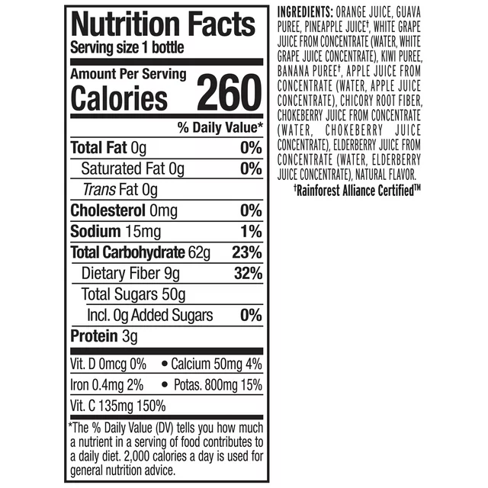

Costco- has small variety pack. **Drink 2** small Strawberry Banana drinks. Each have 25mg- total sugar 50 grams

**Blood Type_____________\***

**Instructions for One Hour Glucose Test**

**For Diabetic Screening in Pregnancy**

**What Is the test?**

OB patients are screened for their risk of developing gestational diabetes between 26-28 weeks. This is a form of diabetes that sometimes occurs in pregnancy and usually resolves after pregnancy. Gestational Diabetes can result in pregnancy complications, so it is an important part of routine prenatal care. The test involves you getting a glucola drink to take home with you.

**How to take the test?**

1. On the morning of the test, eat a high protein breakfast. Wait 2 hours before drinking the glucola drink (except for water).
2. Drink the entire contents of the bottle within 5 minutes
3. Note the time you finish the contents of the bottle and advise the receptionist when you check in.
4. Exactly one hour after you finish the contents of the bottle, our Lab will draw your blood, so please get into the lab 15 minutes early to ensure this is done on time.
5. Be sure not to eat, drink, smoke, or exercise between the time you drink the glucose and the time we draw your blood.

.

**\*If your blood type is RH Negative, to avoid having two blood draws near each other, you can do your glucose test at the same time you do your antibody screen test (which is needed for your Rhogam injection). We do Rhogam testing and injections at our office – Please have glucose and antibody screen test done one week prior to your regular scheduled OB appointment and RhoGAM injection.**

**Instructions for the 3-Hour Glucose Test**

**What is it?**

If your one hour glucose test result is greater than 135, you will need to have a 3 hour glucose test performed in order to determine a diagnosis of Gestational Diabetes. This test involves 4 blood draws over a 3 hour period time.

**How to take the test**

You must be fasting (no food or drink other than water) for between 8-14 hours before you report to the lab. Your blood will be drawn and a glucola drink will then be given you. You must remain in the lab for the remaining hourly blood draws and we ask that you not bring children as it will be important for you to remain calm for the test to be effective.

**Where do I go for the test?**

We are a part of Revere Health, we ask all patients to go to the lab in our building for their test. Please be at the lab between 8:30 and 9:30 a.m. in order to allow for adequate time for testing to be done.

**What if the test results are abnormal?**

There will be a total of 4 glucose results from this test. An elevated level of 2 or more of these will result in the diagnosis of Gestational Diabetes. You will be referred to a diabetic counselor to discuss how to best control your blood sugars during pregnancy for a healthy outcome. Your provider will also discuss these results with you in more detail.