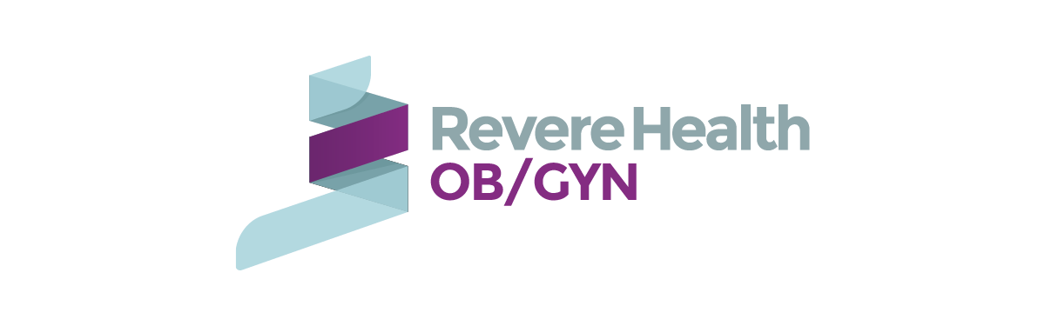Prenatal Classes

Orem:

**Your Empowered Hospital Birth/ Summit Birth**

Taught by Summit Birth Doula Group.

5 week course. Usually Thursday nights 6-9PM in Orem, Utah.

Taught by Charity Wright, children birth educator. Around $350

American Fork:

**Hypnobirthing- The Mongan Method**

http://www.hypnobirthingutahcounty.com/register-for-classes

Five week course usually on Tuesdays (7:00pm) & Saturdays (9:30am)

Contact Launi K. Anderson at 801-225-1251 $250 for 5 weeks

Payson:

**Lamaze Class**

Terah Mottzkus, Payson Utah.

5 week course. Phone number: 385-424-9313. Email: [birthbydesign@gmail.com](mailto:birthbydesign@gmail.com)

Instagram- Birthbydivine design

Provo:

**Mindfully Prepared Birth Class**. By Zena Doula Services.

Saturday's 10AM-12PM, Thursday evenings.

Text or call 435-375-8040 or Email [shealiking99@gmail.com](mailto:shealiking99@gmail.com)

About $250 per couple.

**Birth Boot Camp**

Thursday evening 7Pm-9.

[utahbirthdoula.com](http://utahbirthdoula.com/provobirthclass.html)

$400 per couple

(208)-351-5649 Call/Text  
Hollie@BirthBootCamp.com

South Jordan

**Hypnoactive Birth/Curtis Method**- https://www.hypnoactivebirth.com/

Series; check website to sign up and for days/times.

Contact Lauralyn Curtis at [801-358-1488](tel:801-358-1488), $397 at home study or $427 for in person/zoom class

Online classes:

* **Built to birth-** listen to free online video (30 minutes), class $350 (all of them), Birth course ($199)
* **Christian hypnobirthing**- has a class for $150, also have an app that you can pay monthly has affirmations.
* **Mommy Labor Nurse**- follow on Instagram, podcast. Birth class bundle $100

Recommended books to read**:**

* Active Birth By: Janet Balaskas.
* Childbirth without fear
* Husband-Coached Childbirth By: Robert Bradley
* Ina May’s Guide to Childbirth By: Ina May Gaskin
* Mindful Birthing By: Nancy Bardacke
* Natural- Childbirth the Bradley Way By: Susan McCutheon
* Reclaiming Childbirth as a Rite of Passage By: Rachel Reed
* The Birth Partner By: Penny Simpkin

Podcasts:

* Birth instincts
* Down to Birth
* Mommy Labor Nurse
* The Birth Village

Our Favorite sites:

* Bradleybirth.com
* Evidencebasedbirth.com
* Spinningbabies.com